

Introduction by Ven Sharon Copestake, Archdeacon of Tonbridge

It is with great delight that I commend this profile for **St Luke’s Tunbridge Wells** as you discern God’s call to serve here as Vicar.

*St Luke’s**has a special place in the life of the town. It offers a warm and open invitation, looking outward to serve the community by reflecting God’s love to all.*

*The steady tradition St Luke’s provides, is a strong platform from which the church can build into the future, as it clarifies its identity, and continues to grow and develop. We are seeking a gentle missional leader with a love for Jesus, a longing to bring new disciples to Him, and with a desire to build His church in this corner of Tunbridge Wells.*

*The parish profile reflects the church well, demonstrating their passion for being Christ’s presence in their community, and love for where they live.*

*The challenge for this parish is how to be St Luke’s within the surrounding context of the town. The Tunbridge Wells Deanery is one of six deaconries in the Archdeaconry of Tonbridge. Here you will find a supportive set of colleagues across the breadth of the traditions of the Church of England.*

*Tonbridge Archdeaconry shares its life together under the canopy of the wider diocesan vision whereby we are seeking together the Kingdom of God – called to change, to grow and to serve.*

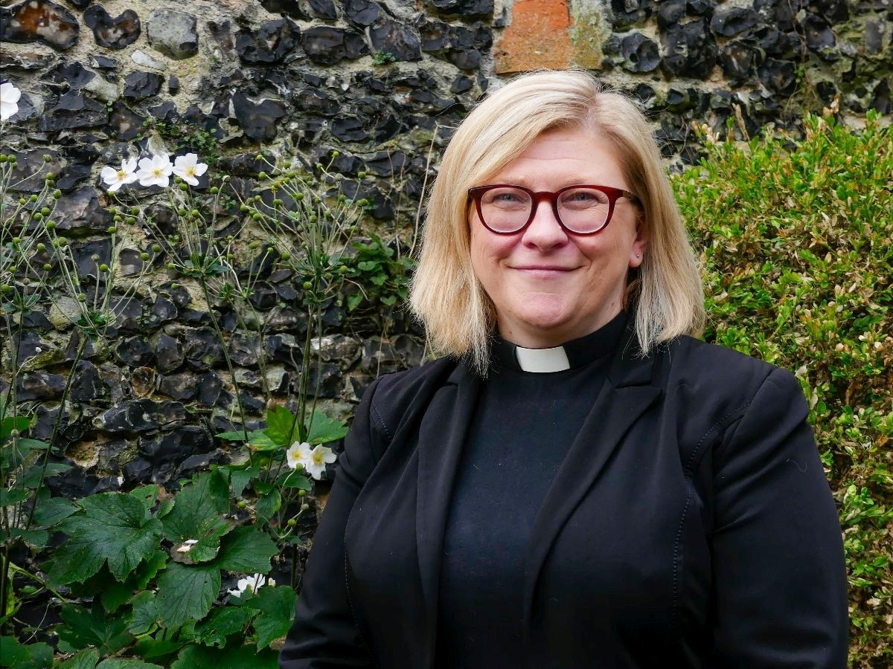*Together, across the Archdeaconry, and across the Diocese, we are working to grow missional churches, leaders and disciples that are younger and more diverse across the many different contexts God has placed us.*

*With prayers for you as you discern God’s call to this place.*

*Ven Sharon Copestake  
Archdeacon of Tonbridge*

*www.rochester.anglican.org*

**CPAS**, the largest Church of England patron, is patron for St Luke’s, and is delighted to be able to support this next stage in their life and ministry.

St Luke’s is a small and caring congregation with a warm love of worship and a heart to share their faith in Jesus with those around them. They are very welcoming to children and young people and would love to find ways to encourage them in their faith. With roots in traditional 1980s Evangelical faith and worship with an ambition for the Gospel and social outreach – we would love to find a leader who can help them grow in confidence in their own way of being local church encouraged but not daunted by the strong Evangelical churches which surround them. We are looking for a vicar who can gently re-energise their faith, help them reconnect with the local school, empower their ministry and build up their team – so that they are ready for a new vision for growth embedded in their own local community.

CPAS is one of the 10 historic Anglican Missions, and for 185 years has been supporting local churches in reaching the whole nation with the Gospel.

Besides their work appointing new incumbents for parishes in every diocese in England, CPAS runs 100+ holidays each year at which children from all walks of life have the opportunity to encounter Jesus and strengthen their Christian faith. CPAS also supports church leaders (lay and ordained) all around the country in their important task of vision, leadership and evangelism.

Our aspirations are currently distilled into four prayers: "Every Church a pathway to faith; Every leader a catalyst for evangelism; Every Christian a courageous witness; Every child the chance to explore Jesus."